This autobiography format is our own. Its seed originated decades ago in Mr. Alvin C. Hamilton’s Honors English class. We have nurtured, grown, and pruned it into a project we hope you will find worthy of your writing efforts.

Parents and teachers, this unit is meant for you to proceed at your own pace. The recommended time frame is a quarter (13 weeks) to allow time for revisions and rewrites. Many have made it longer and more intricate, while others have finished sooner. It is intended for those in at least seventh grade, though it has been successful with mature younger students as well.

We would be interested in hearing how you and your class have fared with this unit. Email us at [Autobiography@LatinTrivium.com](mailto:Autobiography@LatinTrivium.com).

In His grip,

Julie Gentry

Mary Harrington

Push Pens are inexpensive, self-contained units meant to supplement traditional English studies. Only one copy per family needs to be purchased, as the right to copy within a family is hereby granted.

*© 2001, 2015 XL Group. All Rights Reserved.*

**I. Introduction**

**What is an Autobiography?**

Very simply, an autobiography is a story about your life. Who knows you better than you? An autobiography differs from a biography in its format – a biography is written in the third person while an autobiography is written in the first person. Do you remember the difference? In the third person (a biography), the writer is telling *about* another person.

“In the thick of party conflict in 1800, Thomas Jefferson wrote in a private letter, ‘I have sworn upon the altar of God eternal hostility against every form of tyranny over the mind of man.’” *(A Biography of Thomas Jefferson)*

In the first person (an autobiography), everything comes from the writer’s point of view. It is as if you are looking through his eyes.

“When the famous Resolutions of 1765, against the Stamp-act, were proposed, I was yet a student of law in Williamsburg. I attended the debate however at the door of the lobby of the House of Burgesses, and heard the splendid display of Mr. Henry's talents as a popular orator. They were great indeed; such as I have never heard from any other man.” *(Thomas Jefferson’s Autobiography)*

In this autobiography lesson, you’ll be writing with facts, opinions, and fiction. All will come from your point of view. The reader will be able to step into your shoes and see things through your eyes.

**Why Write an Autobiography?**

The main reason is to introduce to the world (and your readers) to the wonderfully unique YOU! You are like none other, created in God’s own image, and knit together in your mother’s womb in a fantastic and distinctive way. God’s plan for your life is different from any other person’s, and the skills and talents that He gives you equip you for life ahead – your life, your path, your responsibilities, and your ministry. Memories fade as you enter that life ahead, but written documentation lasts.

As you write your autobiography, write it as a book. You don’t need the Roman numerals. They are for instructional purposes only. Your book should flow like a story, because that’s what it is – the story of your life.

Use pictures where applicable, especially pictures of *you*. You can color copy the originals and paste in the copies. That way, the originals stay safe in your parents’ albums. This is a fun unit and is not meant to be drudgery. If you are struggling with any of the parts, talk to a parent and ask them to tell you stories of when you were little.

**I. The Process of Writing Your Autobiography**

With the exception of the Journal section, you should work on the pages to mastery. In other words, go ahead and write a rough draft. Then correct it and revise it until it is just perfect. Sometimes you get a picture in your mind that does not easily translate into words. You might know what you want to say, but it is not coming out clearly. That is what revisions and editing are for. Write, correct, revise, and write again. Repeat as necessary.

Your teacher will tell you whether to type out your pages or hand-write them. Though typing them will give it a uniform look, handwriting them is very personal and gives the book an heirloom quality. Each way has its own benefit. If you do decide to type it out, at least do the journaling section in your own handwriting.

Are you thinking about what you will include? This book is set up to guide you through various sections step-by-step, but you may choose to include more photos and more information. When completed, it will be a treasure to keep and a snapshot in time.

**II. Title**

**What a Title Does**

Your title, though very small, is of great importance. It draws your reader in for a second look. If you are renowned in your field or easily recognizable, you might want to use the same title that Thomas Jefferson, Benjamin Franklin, Frank Lloyd Wright and Roald Dahl did. Can you guess it? Yes, it is simply “Autobiography.” Most of us need something a little flashier. Your title should tell the reader in one concise statement what your book is about. Can you match the autobiographies below with their authors?

Up From Slavery Billy Graham

Ace! Ronald Reagan

Just As I Am Booker T. Washington

An American Life Mother Teresa

Everything Starts from Prayer Mel Paisley (WWII fighter pilot)  
  
Can you see how effective a few simple words are? Your assignment for this class is to come up with a title for your autobiography which reflects YOU. Those who know you best should be able to pick your title out as yours from any dozen. Brainstorm. Write down everything that comes to mind, no matter how silly or far-fetched it initially sounds. You’ll be discarding all but one of them anyway.  
  
If you are completely stuck for a title and can’t even brainstorm anything, it’s okay to come back to it at the conclusion of your writing. Sometimes it helps to have everything else laid out before tying it together with a title. Whether writing it first or last, however, the title deserves a lot of thought. It is that lure to attract your reader.

**III. Introductory Paragraph**

After your title page comes your introduction. This is a one-paragraph summary of your life. It should be something that can be read in less than a minute. This page is to convince the reader that he wants to continue. Your title page caught the reader’s eye. Your introduction hooks him for a closer look.

Your introduction deserves its own page. Choose something interesting from your life and expand on it. What is it about YOU that is going to make ME want to read further?

In our sample autobiography, the sentence, “I was born on a sunny afternoon in April, and the sun’s been shining on me ever since,” makes me want to know what about his life is so good and what it is that makes him happy.

If your introductory paragraph starts with, “I’m doing this book because it’s part of my class,” is that going to make the reader want to continue? It’s doubtful. Every person who has ever lived is interesting; with some, you just have to dig a little deeper. Each of us has a story to tell. Use this paragraph to make your reader want to find out just what it is that makes you tick.

Which of these actual autobiography introductions makes you want to continue?

“Dear son, I have ever had pleasure in obtaining any little anecdotes of my ancestors.” *(Benjamin Franklin)*

“My line comes down from Queen Ada, the sister of Malcolm IV, descended from King Duff, the first King of Scotland.” *(Johnny Cash)*

“I was born the 30th of November, 1835, in the almost invisible village of Florida, Monroe County, Missouri. My parents removed to Missouri in the early thirties; I do not remember just when, for I was not born then and cared nothing for such things.” *(Mark Twain)*

“So many misstatements, wittingly or unwittingly, have been made regarding my father and me that I wish here to set down the facts of my life – and some of his – as they truly were.” *(George Washington – a biography written as if it were an autobiography)*

**IV. Coat of Arms**Your personal Coat of Arms is next. Copy the blank one on the next page or draw your own. Your Coat of Arms should reflect your personality and your character. It should be a statement of who you are.Proverbs 22:1 tells us that “A good name is rather to be chosen than great riches, and loving favour rather than silver and gold.” The Coat of Arms is important because it is a symbol of your family’s pride and honor, your “good name”. That good name goes across the top. What kind of name is it? Your lettering style is important. Is your last name on the plain side? You could either block print (keeping with it being plain), or fancy it up with intricately drawn script. The length of your name need not necessarily determine the size of the lettering.Next, choose two colors for the backfield. Colors evoke emotion. What do you think of when you see purple and gold? How about pastel pink? Bright red? Through experience, we have attached emotions to different colors. Though each of us is unique, colors affect many of us in the same way. There is a reason that fast-food restaurants are orange and yellow. “Hurry!” comes to mind for most patrons and employees alike. Likewise, we see pastel pinks and blues in nurseries and hospitals because they are calming. Choose colors that reflect your individual personality. What might your descendants think if you used black and white? Purple and gold? Choose with a purpose.  
  
Now think about four things that you will always love. What things are important to you? They can be an idea (truth), a person (your mother), or something tangible (books). Anything at all that reflects what is important in

your life. Choose wisely. “Pizza” probably isn’t the best choice. Will it still be important to you when you’re fifty? Probably not. However, your best friend or your dog may very well be. Cut out something from a magazine to represent each of your choices or create your own icon.Lastly, choose a phrase that has meaning for you. It should not be overly wordy; four or five words maximum. Would you be proud for your ancestors to have had “ad maiorem Dei gloriam” or “Faithful servants of the king” on their coat? I certainly would.Remember, your book is for posterity. Don’t choose things like chocolate or root beer. You may not always love them. Similarly, do not choose a phrase that won’t have the same meaning to your grandchildren. Avoid slang. Years down the line, “I’m really cool” might not mean exactly the same thing as it does to you.

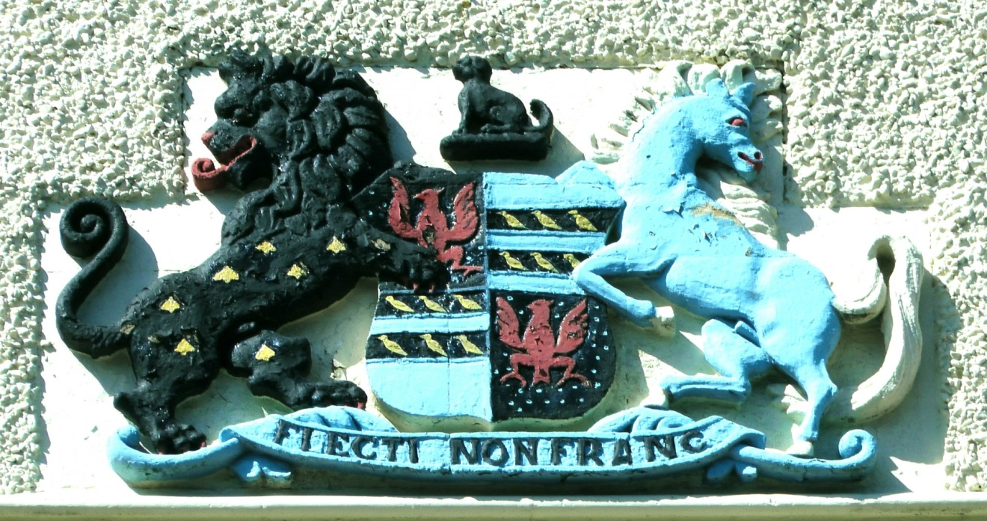



**V. Your Family Tree**

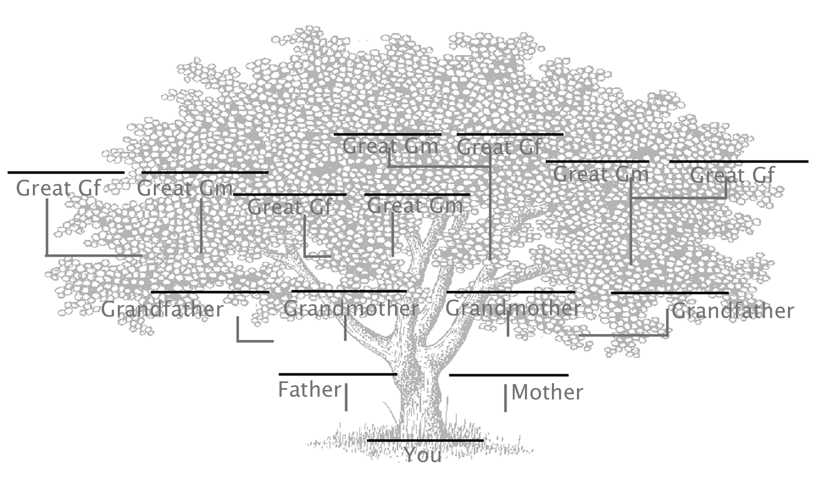

The concept of a family tree comes from Isaiah 11:1, which speaks of the lineage of Jesus. “And there shall come forth a rod out of the stem of Jesse, and a Branch shall grow out of his roots.” A family tree helps to trace that lineage, showing members added through birth, marriage, or adoption. The tree generally contains not only the names, but dates of birth and often occupations or place names. You can choose how much detail to add, and whether or not you want to include photos. For your tree, use the template on this page or make one of your own. Many of us have non-traditional families and may want to add connecting lines to show additional parents or grandparents. Note that this tree originates with you, and does not include siblings. If you wish, you can make a more elaborate tree that shows all the branches and shoots. After you’ve completed the tree, write a paragraph or more about the people in it.

**VI. Physical Description**

Your physical description should enable someone looking through your autobiography fifty years from now to be able to pick you out of a crowd. Why include a physical description? Mostly out of curiosity. Do you ever look at old family photos? Where did you get that ridge of freckles across your nose, those dimples, or that baby-fine hair? Genetics are amazing and it is very interesting to see particular family characteristics throughout the branches of a family tree. Each of us is created in the image of God and there is His beauty in every one of us.

For this assignment, write a physical description. You can start from top to bottom or from feature to feature. Compare yourself to your relatives. Is your lion’s mane similar to Auntie Stefanie’s? Do you have Uncle Mike’s perfect smile? A little toe that curls under like Grandma’s? Document it here! Tie your hereditary traits into your family history. “My ancestors were Irish potato farmers, and I inherited that sturdy Irish peasant stock frame. God definitely crafted me for strength.” What does that person look like?  
  
At a minimum, include your most striking feature, a comparison to at least one relative, and what you like most about your physical self. Include a photo or a drawing on your page to make it visually more interesting. The more pictures, the better.



**VII. My Earliest Memory**

This page doesn’t have to be long, but it requires a great deal of thought. Sit quietly and think. What is the very first memory you have? Is it the song of the ice-cream truck when you were five? Eating dirt when you were three? Something even younger? Dig deep into the recesses of your mind. What little things have been filed away there? Memory is such a funny thing. Sometimes we remember the ‘littlest things’, yet forget the big picture. How far back can you go?  
  
Describe as much as you can remember: your surroundings, anyone with you, your feelings. “I remember the merry-go-round at Knott’s Berry Farm” is not enough. WHAT about the merry-go-round do you remember? Describe its physical characteristics visually, the sounds you remember, the smell of the air. What was the weather like? Who was with you? Was there laughter? Music? What were your surroundings like?  
  
Be as detailed as you can. Your memory doesn’t last forever and memories change over time. Refer to your example if you need a starter.

**VIII. Home, Sweet Home**

“There’s no place like home, there’s no place like home, there’s no place like home.” It’s where most of our memories originate, a place where we’re always loved, and an anchor in times of trouble. Our home.

Use these pages to describe every place you have ever lived. For some of you, this will be an easier assignment than for others. For those of us who have moved around a lot, it is a fond look back at all the places we have called home. What makes those houses “home”? It isn’t just the tangible things. It is the atmosphere and the people in it. It’s your neighbors, the bread baking in the oven, and the smell of babies. This is more than a simple physical description. You want to give the reader a “feel” for those homes. Did the house have some unusual characteristic? “The old brick coal bin in the basement made the perfect hideout for us during a game of hide and seek.” What was your favorite part about the house? What was the yard like? “When I look at it now, the backyard doesn’t seem very big, but to a five year old it felt like a football field.”

You should already be familiar with metaphor and simile. In brief review, a simile compares while a metaphor takes the place of something. The Bible is full of metaphor and simile. It’s important to know which is which. Matthew 13:31 reads, “The kingdom of heaven is like to a grain of mustard seed, which a man took, and sowed in his field: Which indeed is the least of all seeds: but when it is grown, it is the greatest among herbs, and becometh a tree, so that the birds of the air come and lodge in the branches thereof.” That’s a good example of simile. Jesus is not saying that heaven is a mustard seed, but he is COMPARING its growth to that of the mustard seed. John 6:35 tells us, “And

Jesus said unto them, I am the bread of life.” Did Jesus actually mean He was a

piece of bread? No. It’s a metaphor. Are the following passages using metaphor or simile?

John 15:5 “I am the Vine; ye are the branches.” _________________

Matthew 23:27 “Woe to you, scribes and Pharisees, hypocrites! For you are like whitewashed tombs which indeed appear beautiful outwardly, but inside are full of dead men’s bones and all uncleanness.” _________________

James 1:6 “For he that wavereth is like a wave of the sea driven with the wind and tossed.” _________________

For this page, describe each home in a paragraph or more. In at least one description, use an example of metaphor. In at least one other, use simile.

In the example autobiography, this section is one page long. Use as many or as few pages as you need to convey how you feel/felt about each place you have lived. Remember, this is *your* book. The more detail you put into it, the more valuable it will be in years to come. Make sure to include a drawing or photo of your most favorite home.

**IX. My Family**

Ah, there is nothing quite like family. We sometimes bicker, wrestle, or jockey for positions of favor, but family is something we can always count on. No matter how much distance separates us, physically or emotionally, we are always interested in each and every member of our families. They are such a part of who we are. Your family belongs here in the center of your

autobiography as in the center of your life. God designed the family with

specific purposes in mind. Your family shapes you, molds you, and rubs off the rough edges. It supports you and strengthens you. Most importantly, it loves you unconditionally.   
  
Describe your family here. First, write about your family as a whole. How does being in this particular family feel? Why might God have chosen to place you in this family? Why do you think your family has four children? Or just you? Or a dozen? If you look at families in the Bible, they’re all different. Do you think John the Baptist would’ve had the same personality if he had been the middle of nine children? How about Joseph? If he had been the oldest, how might he have been different?   
  
After you write about your family as a whole, write about each individual member, using at least a paragraph per person. Use physical description, tell what you admire about them, list some of their talents, and tell what makes them unique. Resist the urge to settle scores here; writing it down is for good. A good rule to remember is, “Never put anything into writing that you wouldn’t want the whole world to see.” Include drawings, or photos if you have them.

**X. My Journal**

If you don’t already keep one, begin a journal this week. Write at least a paragraph in it each day. How do you keep a journal? It is really not as difficult as you might think. A journal simply journals, or records, a period in your life (for our purposes, a day at a time). Tell about what you did, how you felt, what the Lord is teaching you, or even what you had for dinner. You don’t need to try to be funny or clever (unless that’s the normal you). Just be yourself. After writing in the journal for the week, pick out three consecutive days to add to your Autobiography. Why only three? Often, when people first start a journal, it takes a few days for them to be comfortable. You want to include those pages which best reflect your thoughts and feelings.

**XI. Pie of Life**

Where a person’s time is spent says a lot about them. Our great-grandmothers spent much more of their day in the kitchen than most modern mothers do. Our grandfathers may have worked much longer hours, as well. How about schooling? Church? Leisure activities? As technology and culture change, so does the amount of time we put into different pursuits. The Pie of Life serves not only as a record of how your time is spent, but as an exercise to reflect on where that time is going.

The Pie of Life is a time management tool. It is putting down in black and white (or color) the hours of your life. To do this exercise, write down what you do with your typical week. Your journal may help here. Group like activities together. All grooming and showers could go in a single category, as could all church activities or studies. Now add up the hours and divide by seven. That’s your average daily amount of time spent.  
  
What surprises did you find? Other than to have it stare at you that over a third of your whole life is spent sleeping! Are you spending too much time in one area and not enough in another? How we spend our time shows our priorities.

Copy the pie on the next page (or draw your own), and divide it according to your daily averages. Use six or seven of the main categories. Now find a picture to represent each of the blocks of time. Comment on each category on a separate page.

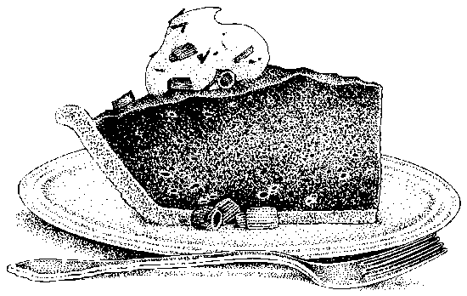

(No, not *that* kind of pie!)



­­

**XII. Greatest Achievement to Date**

What is the greatest thing you’ve done so far in life? Why is it so memorable? Did you recite the Pledge of Allegiance at age two to the amazement of friends and relatives? Score the winning soccer goal in an important game? Save a kitten from a tree? God gives each of us interests and personalities that are unique. We are all part of one body, and a body needs diverse talents. What things interest you? What you are interested in now could become your passion or profession later. Do you stare at the stars and long to be up there? Perhaps God is already shaping you to be a physicist. Are you the one who saved that kitten? Maybe His will is that you become a veterinarian. Do you have a love for younger children? You may be a mother, teaching future generations of godly leaders.

Write down your greatest achievement. Don’t simply narrate a few sentences. Fill it out. Think about why you are drawn to that particular interest. Describe it. What else are you interested in that is related to it? What plans do you have to pursue it? This achievement may not be something huge. It could be a small thing, but something important to you. Remember the old nursery rhyme, “Little drops of water, little grains of sand, make a mighty ocean, and a pleasant land.” All those little things combine to be great.

**XIII. An Unusual Experience**

Abraham Lincoln said, “In the end, it's not the years in your life that count. It's the life in your years.” What he meant by that is that life is made up of experiences. It is not the common, everyday events that stick out in most people’s minds. Rather, it is those that are unusual that become lasting memories. Think about an experience that you have had. It could be something that has happened once or it could be something recurring. This section might take a little more thought than some others, but rest assured, you have had an unusual experience somewhere along the line. Remember, too, that what is “usual” for you might be unusual for many. Write about it here, using pictures if you like.

**XIV. What Makes Me Happy?**Are you happy? What is it that makes you so? If you are a Christian, you have a joy that defies explanation. That comes from Christ Himself. But what are the tangible things that make you happy? Is it seeing a sunset? Is it having a pocketful of your allowance?In this section, write about ten things that make you happy. Don’t just list them; tell why they make you happy. When you look back in twenty years, you might be very surprised to find that many of the things that make you happy do not change. Most people are happy with simple things. If you find yourself listing tangible items such as money or gifts, make sure you write about why they make you happy.

**XV. Flights of Fancy**

What a great big beautiful world the Lord has made for us! We are so blessed to live in a nation built upon godly principles and laws. Though keeping those freedoms and laws is a constant struggle, there is no better place to live than in the good ‘ol USA. There is a “world within a country” here, and so much that most of us will never have the opportunity to discover.

Imagine that you have a private jet at your disposal. Where will you go? Will it be off to see Niagara Falls? Yellowstone? The wheat fields of Nebraska or the dude ranches of Montana? The killer whales in Washington or the sunny beaches of California? Such diversity in one nation!   
  
Write at least a paragraph about three different places in North America that you would like to visit one day. Tell why you would like to go, and what you would expect to see there.  
  
Complete a second page, this time writing about three places outside of North America that you would like to see. Tell us about what you expect to find, who you expect to see, and what you expect to do.

**XVI. People Who Have Influenced Me**

Those people that you admire may or may not be people you know or are likely to meet. Many people admire George Washington, but no one alive today has been directly influenced by him. For this section, choose three people who have impacted your life. Since it is a given that your parents have been great influences on you, choose three people outside of those in your household.

Tell how each of them has influenced your life. What godly characteristics do they possess? How do they show the love of God in their daily lives? At a minimum, write a paragraph about each of three people. Try to give your reader a feel for why they are important to you. It’s interesting to think back how our lives might have been different without those who have influenced us. Did you know that YOU influence other people’s lives, too? Hebrews 10:24 reads, “And let us consider one another to provoke unto love and to good works.” That love is not mushy feelings; it is action. Every kind word you speak and every good work you do makes someone’s life better. Whose life have you influenced this week?  
  
Brainstorm below. Just off the top of your head, list everyone you can think of who has an influence on your life. We have given you a couple of likely influences to get you started. List as many as you can, then think about each one of them. Who has influenced you the most? Whose positive example do you want to emulate? Which person has made you a better person?

Pastor: ______________________________________________

Favorite Teacher: ______________________________________

Your Best Friend: ______________________________________

A Neighbor: __________________________________________

A Relative (outside your immediate family): _________________

**XVII. If …**

The things we wish for and want tell a lot about a person - not necessarily good or bad - but simply providing an insight into a person’s needs, desires and motivations. Answer each of these questions with a paragraph or so, and do so honestly. The answer to, “If I had ten million dollars, I would…” is not “…give a thousand dollars to the first thousand people I met.”

This section of your autobiography should not have rough drafts and revisions. It should flow from the top of your head. Be honest about your answers; don’t try to give answers that you think will make you look good. They will be easy to spot as contrived, and will defeat the purpose of an autobiography – to get to know *you*, with all your wonderful foibles and uniqueness.

Answer the following five questions truthfully, using a paragraph or more for each response. Do not write the question in your autobiography. You may, however, begin your paragraph answering the question (i.e., “If I had ten million dollars, I would…”)  
  
(1) Congratulations! You have just been handed ten million tax-free dollars to spend any way you like. It has to be spent by the end of the week or you lose it, and no fair putting it into savings, investments, or the bank. What will you do with it? Have you ever played this mental game with yourself? Now is the chance to lay it out and spend the cash. Tell us about it, where the money goes, how it makes you feel.  
  
(2) Hail to the Chief! You are President of the United States of America! But just for today. What three things do you do?

(3) If you could change one thing about yourself, what would it be? Why?

(4) You have found H.G. Wells’ time machine. It is a little dinged up, but it’s working. You notice that only the reverse works, and there is a counter showing that there are only three trips remaining. Which three historical figures do you go back in time to meet? Why?

(5) It’s a Freaky Friday! Which person that you know would you most want to change places with? Who do you know that you would like to be for a day? Why? Remember, this is someone with whom you are well acquainted, not a public figure.

**XIII. Whom Do I Admire?**

Everyone needs heroes. Who are yours? Why? What characteristics do they possess that make them heroic? Choose up to three people you consider heroes and tell how you feel about them. Include at least a paragraph per person.

**XIX. My Future**

We do not know what the future holds. God has a plan for each and every one of us, and it is not always immediately visible. But, Lord willing, what possibilities can you see in your future? Write them down now. You may be very surprised to reread them in ten or fifteen years.   
  
Will you be married? Describe your future spouse. Will you be working? What will you be doing? Describe the job. Will you have children? How many? Describe them. Where will you live? This is an imagination exercise. Nobody will be 100% correct. It’s all in fun.  
  
Write at least a paragraph predicting what your life will be like in five years, fifteen years, and twenty-five years.

**XX. The Wisdom of the Ages**

Imagine you’re sitting on the porch swing rocking with your great-grandchild, recalling the days of your youth. What advice do you give to this twelve year old? What would you say? What pitfalls would you advise him to avoid? What words of wisdom to you have to share?   
  
You are having a long and deep conversation. You have grown in wisdom as you’ve aged and lived in grace, taking to heart Psalm 111:10, “The fear of the Lord is the beginning of wisdom: a good understanding have all they that do his commandments.” You long for him not to make the same mistakes you have made, and for him to follow your advice. What do you tell him? Use this exercise to imagine telling him the secrets to a good life.

**XXI. Epitaph**

In the scope of eternity, our lives are but a breath. How humbling to think that the Son of God died on a cross for little ol’ me. It is amazing and wonderful. He rose again, but many of us will sleep before His return. Here is a chance to write your own gravestone. Graves are a place for the living to grieve and heal. For a Christian, they are but the beginning of another chapter.

For this exercise, choose three words that you would like on your headstone. How do you want to be remembered? Here are a couple of famous ones:

“He thinketh no evil” – Henry Ward Beecher

“That’s All Folks” – Mel Blanc

“At Rest, an American Soldier, and Defender of the Constitution”   
– Jefferson Davis

“Steel True, Blade Straight” – Sir Arthur Conan Doyle

“Man must endure his going hence.” – C.S. Lewis

My favorite is Roy Rogers’. It must be a pretty big stone…

The Cowboy's Prayer   
Oh Lord, I reckon I'm not much just by myself.   
I fail to do a lot of things I ought to do.   
But Lord, when trails are steep and passes high,   
Help me to ride it straight the whole way through.   
And when in the falling dusk I get the final call,   
I do not care how many flowers they send--   
Above all else the happiest trail would be   
For You to say to me, "Let's ride, My friend."   
Amen

For your stone, think of three words that describe you. They should be words that would let your great-great-grandchildren know who you were. Words that evoke emotion or imagery are much better than words that are flat.

Which word is deeper, conjuring up a more vivid image? Spouse or Help-meet? Politician or Statesman? Laughing or Joyful? Doctor or Healer? Do you see that the second word of each pair conveys so much more than the first? Try to choose words for your tombstone that encompass your life. Remember to use words that are likely to remain largely the same over time. Slang such as “cool” or “sports-crazed” may not mean the same thing to your children as it did to you. Put these three words or short phrases on a drawing of your tombstone.

**XXII. Fiction Story: A Story about Me**

This is the lengthiest part of your autobiography. It is an adventure story that is totally made up, starring *you*. It may be a spy story or a trip to the moon. Something fairly unrealistic, following the rules of "Want, Struggle, Surprise.” Let your imagination run!  
  
The story should be two full pages minimum, preferably longer. Include pictures that are relevant. This is a chance to use all the tools you have been practicing in the rest of your autobiography – things such as description, narration, and imagination. Here is your chance to be Joan of Arc, Ollie North, Mary, Thomas Jefferson, or Bugs Bunny. Let your imagination go!

Some of those we have particularly enjoyed include:

An Alien in Mrs. Hawley’s English Class – Me!

The Adventures of Super Dog and Pup Wonder

008 – The Real Story

How I Invented the Internet

Around the World in 180 Minutes

Why I Let Beethoven Take All the Credit

**P.S. The Cover**You’re finished! What a magnificent piece of literature! And such a treasure deserves a great cover. Now that your imagination is running at full speed, design a personal cover that reflects the ideas and thoughts in your book. Are you straightforward and logical? Fanciful and full of whimsy? Let the cover reflect that. Once you are finished, make a copy to store somewhere safe so that you will have it in fifteen years to look back on. You will be amazed how much the same, and yet how different you are. Wrap the original as a present to your mom, dad, or favorite grandparent.

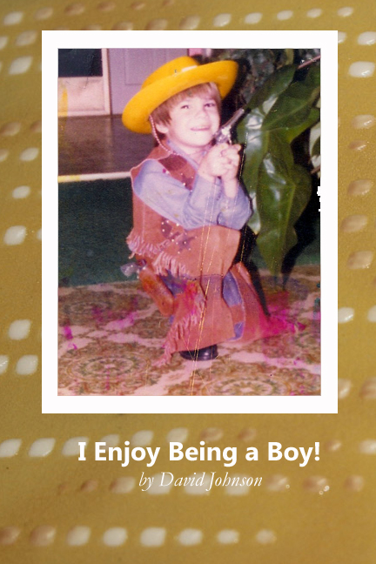“Hooray, it’s David!” “Oh, David dear.” “David Melvin Johnson, come here right now!” No matter how it’s said, it’s me. Everybody seems to want me for one reason or another. I prefer when it’s because there is ice cream on the table rather than something spilled on the floor. I can be funny, serious, studious, and mischievous – all at once, if need be. Because I am DAVID, all boy and all fun. I was born on a sunny afternoon in April, and the sun’s been shining on me ever since. I have a great life!



My future’s so bright; I need to wear shades…

**Coat of Arms**

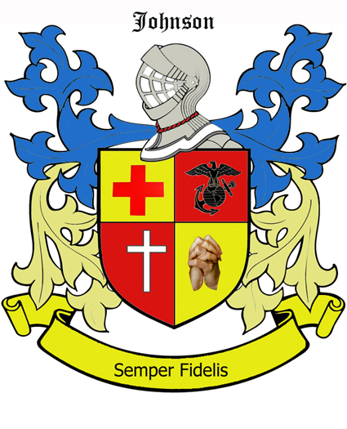

This is my coat of arms. I chose red and gold for background colors because they are the colors of the Marine Corps, and make me think of strength, honor, and faithfulness. My Great-Grandpa Fred was a Marine, and I have grown up hearing the stories of sacrifice and honor that he and his fellow Marines made in World War II. I also used blue at the top because blue makes me think of peace, and peace is what the men in the military are fighting for. The words I chose for the banner are “Semper Fidelis” which is Latin for “Always Faithful”. It’s the Marine Corps motto and I think it is beautiful. It sums up the man I want to be in two words: one who always keeps his commitments and is responsible. Plus, I like Latin class so I wanted to have some Latin in my autobiography. For my four symbols, I chose things to represent God, church, medicine, and the Marines.

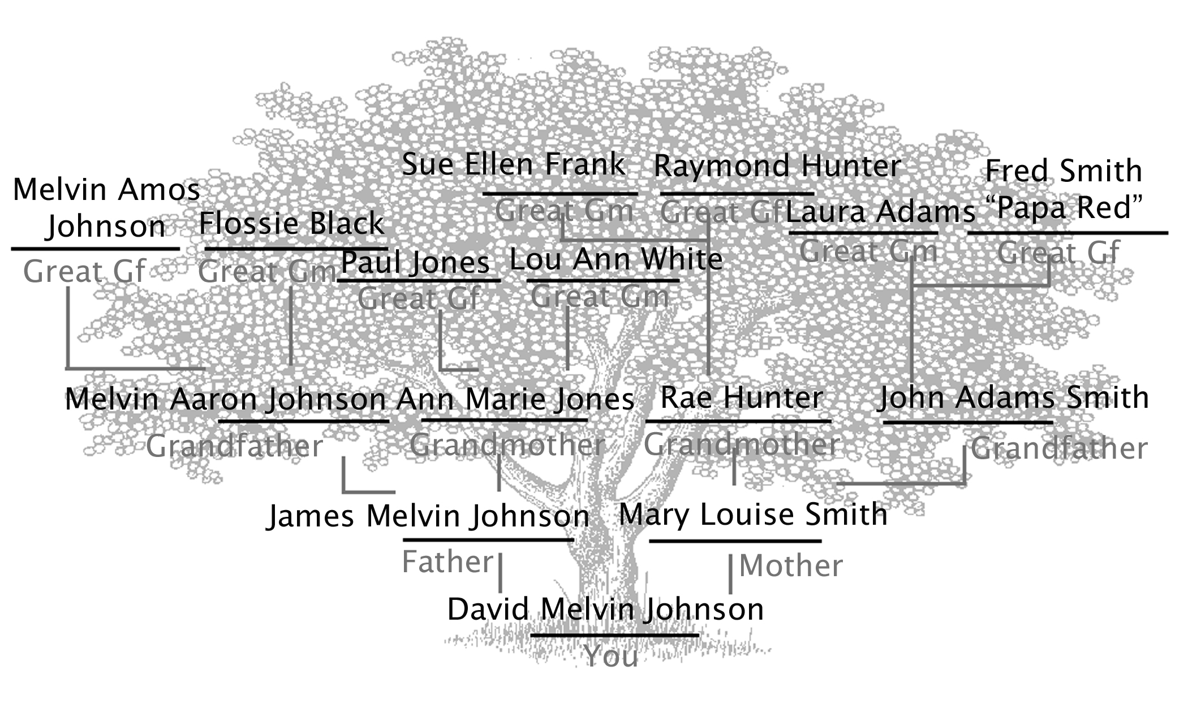**My Family Tree**

That’s my family tree. It’s kind of interesting to look at. I guess I should be thanking my dad that my *first* name isn’t Melvin! I didn’t get a chance to know my grandparents on my dad’s side, but both sets of great-grandparents on my mom’s side are healthy and hopefully going to live a long time. I love them all, but Papa Red has a special place in my heart. They live close to us and I get to see them a lot. He takes John shooting and sometimes I go with them.  
  
My Grandma Laura is related to the former president, John Adams (and, of course, John Quincy Adams). My brother’s name is, yep, you guessed it, John Adams.

**Physical Description**

I am a regular twelve year old boy, who is starting to grow tall. At least my mom keeps telling me I'll grow! My hair is thick, reddish-brown and in need of a haircut. I have freckles across the bridge of my nose. There’s one big one on the bump of my nose, and that seems to be a family characteristic. I am pretty strong, but not really muscular. Dad says I’m “wiry” because I can wiggle out of just about anything.

What I like best about me is my smile. My teeth are very straight, even without braces. I am pretty good about brushing them and they are white. I am happy and smile a lot. Like the rest of my family, I have a thin upper lip that seems to disappear when I smile wide. My eyes are medium brown like cow’s eyes. They have flecks of gold in them which Uncle Joe says means I will be wealthy someday. I think he’s making that up.

I have Mom’s little ears, a good thing since Dad’s stick out of the side of his head (he can wiggle them, too!) My body is slim, but not skinny. My legs are normal size, but my feet are huge. When we play volleyball, they use my shoes as line markers. John says that if there was ever a flood, we would be safe because we could use my shoes for boats!

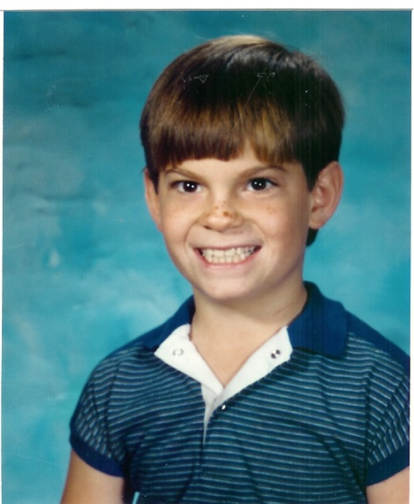

Out of all my relatives, I look most like my Uncle Mike. He is a handsome guy, too. This is a picture of me when I was ten. I look pretty much the same, only bigger. I needed a haircut back then, too.

**My Earliest Memory**

When I was little, I had a cat named Tiger. I don’t know how small I was, but I was still in my crib, so maybe about two. Tiger would sleep with me. He was a big, old, ugly tomcat, but other than my family members, he was the most beautiful creature I had ever seen. He would let me lay on him and use him like a pillow. The earliest memory I have is feeling his soft fur against my face and hearing him purr as my little hands patted him. I remember that it was dark, but it didn’t matter because I could see him. I remember him as grey, but my mom says he was orange and white. He was fluffy except for the spots where his fur had been ripped out in fights. I loved Tiger. I don’t remember what happened to him, but I remember holding him and listening to him purr when I lay against him.



**Home, Sweet Home**

Born in Michigan, I moved to California when I was seven years old. I liked the big old house we had lived in while we were in Michigan. It had two stories and an attic, and to my little eyes, it seemed like a mansion. My brother and I would play tag on all three levels, making a ruckus as our feet pounded the wooden stairs and floors. The stairs were carpeted at first, but we had slid down them so many times on boxes that Mom eventually had the carpet removed. It was a place of wonder to me, and I spent many afternoons dreaming I was a knight and it was my castle. All the bedrooms were on the second floor, and the room I shared with John was right next to my parents’.

Here in California, our house is much lighter with a lot of windows. Dad says it is bigger, but it doesn’t feel that way. It is all on one level and spread out. The style is called Contemporary; all that really means is it doesn’t have a lot of built-ins or fussiness. I have my own bedroom here which is nice sometimes, but lonely at other times. My brother has his own room, too, but my sisters share. We have a swimming pool in our back yard, and all the neighbors come over to swim and play ping-pong on our patio during the summer. I have heard that this is a good way to make friends, but maybe they only like us for the hole in the ground. The pool is the best part of the house and where I spend most of my time when I can. I especially love the spa with the whirlpool jets. We can fit fifteen people in it even though it’s only made for four. This is supposed to be the best place to live, but since I have so little experience, I'll just take your word for it.



**Our house in Michigan**

**Meet My Family**

My family is pretty normal in some ways. We have a dad, a mom, and four kids. We like to do outdoor things a lot, like camping, fishing, and taking vacations. In some ways we are pretty different than most people. My dad works at home. That is pretty cool most of the time. I think God might have put me in this family because there is a lot of love here. Also, mom is kind of a serious type of person, and needed someone like me to keep her laughing.

My dad's name is Jim. He is forty-two this year. He is really strong, and he can always lift one of us up if we need him to. Forty-two seems pretty old, but my dad looks really young; I think about thirty. He works out of the house on the computer, so we get to see him every day. He teaches us science twice a week, and we like that little book, Backyard Scientist, which we use. He is an elder at church, so we help clean the church on some Saturdays. What I like most about him is that he is really funny. He plays a lot of jokes on my mom, which she pretends not to like, but really does. And he likes to play with us a lot, too. He is a great dad!

My mother's name is Mary, and she is thirty-eight years old. She has blonde hair, and she is really pretty. She looks really young; she says twenty-nine every birthday, but we all know that she isn’t really that young. She spends all her time taking care of us, exercising to one of those videos, and cooking lots of good food for us. I really appreciate her. She is a good listener, except when Michelle just keeps talking and talking about nothing. She is kind of a quiet person, but happy.

There are four children in our family: my sister Michelle who is eight, my sister Jenna who is ten, my brother John who is fourteen and me… I'm twelve. Michelle is the baby, so we all watch out for her. She mostly plays dolls and rides on her scooter. She has blonde hair and blue eyes and is very, very strong - probably stronger than even my brother (but not stronger than I am). She is a tomboy and she is tough. She even likes bugs. She sings all the time and loudly because she is happy. Sometimes she talks and talks and talks like she is never going to have another chance to say anything ever again. She has a lot of friends, and they talk a lot, too.

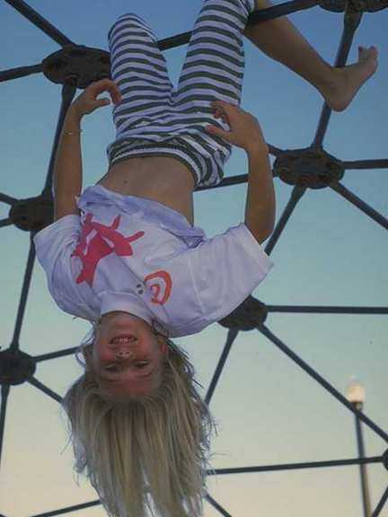

Jenna is the opposite. She likes to play chess and she just qualified for the state championship, so we will all go there in April. She is so good that I don't like to play against her! She is tall and pretty, with dark brown hair and big, brown eyes. She is definitely a girly-girl who is afraid of spiders and snakes. She likes horseback riding and reading books. That’s a picture of her picking daffodils.

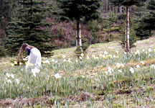

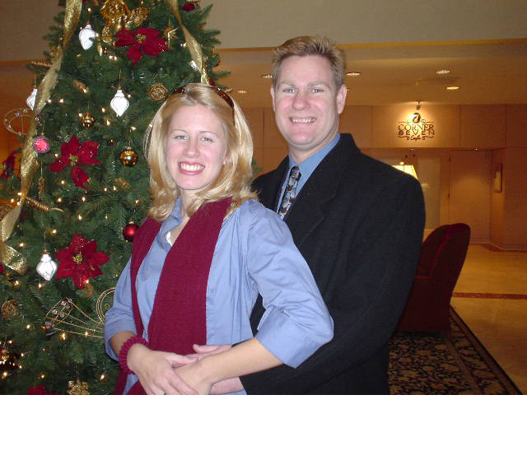John wants to go into the Marines. He lifts weights all the time and runs on the treadmill. My dad and he go to the shooting range for target practice. He brings home his targets and he gets a lot of bulls-eyes. He is also in Civil Air Patrol. I’m not too sure of what they do, but I have seen them march around like soldiers. It has something to do with learning about flying. He wants to be a pilot and fly the F-14 jets. He is as tall as my Dad, and looks a lot older than fourteen. He likes heights but I don't! He does most of the yard work around the house except when I have to help him. Then he bosses me around. His room has everything just perfect and I am not allowed to touch most of the things in it. My room is, well, not so perfect.  
  
Here’s a picture of my mom and dad before Michelle was born. My mom doesn’t want me to put in a picture of her now because she says this one is her most favorite. I can see why. She is pretty!

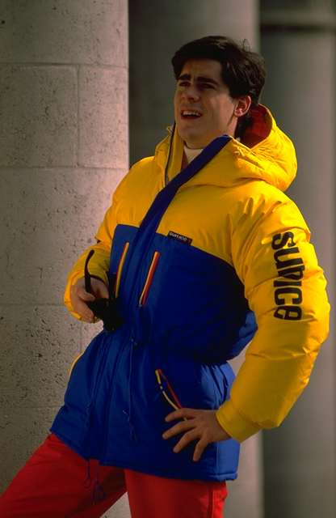

**Pages from My Journal**

Saturday, March 04 – Hooray for Saturday! No schoolwork and only morning chores. John told Dad I could go with him to the airport today. It felt good to be hanging around with him; a lot of times he says I’m too young to go places with him. But we had a good time. Dad dropped us off, and we had lunch at a restaurant at the end of the runway, and there were headphones at the table. I got to listen to the control tower and the pilots while we ate. Then we ran errands with John’s friend, Scott, who just got his license, but Dad says he trusts him. Maybe because he drives a big, ugly, old, huge car that would be hard to do any damage to. Ha ha. One of the errands was weeding Mrs. Keeler’s yard. She’s a strange old woman, but even strange old women need God’s love. It was hard work. On the way home, John gave me an envelope from her. It had $10 in it! I’m tired, but had a great day.

Sunday, March 05 – We went to late service today. I was just so tired that when Mom woke me up, I said, “Five more minutes.” When I turned back over, two hours had gone by. We still made it to late service on time. The sermon was about the different levels of government God designed. How we should first be self-disciplined and if that fails, then family discipline, then church discipline, and finally, civil discipline. It seems that the world has that backwards today. Mom made a big, huge dinner with roast beef, mashed potatoes, and lots of gravy. Oh yeah, vegetables, too, but I kind of mushed them around my plate instead of eating most of them. Why would anyone eat cauliflower on PURPOSE?

Monday, March 06 – I was actually excited to go to school today. We got to make ice cream in Chemistry class. We used liquid nitrogen to freeze it. It was delicious! And in Math, I found out I got an A on Friday’s test. I can’t believe it. That’s the first A in Math I’ve gotten all year. Mr. Engel is a really hard teacher, but I really like him. I ate lunch alone today. It was just so beautiful outside that I wanted to sit under a tree and enjoy it alone. I hope Philip doesn’t think I was mad when I didn’t eat with him. After school, Dad picked me up and we went out for more ice cream. Sometimes I feel so blessed that I could just burst! Today was one of those days.

­

**Pie of Life**

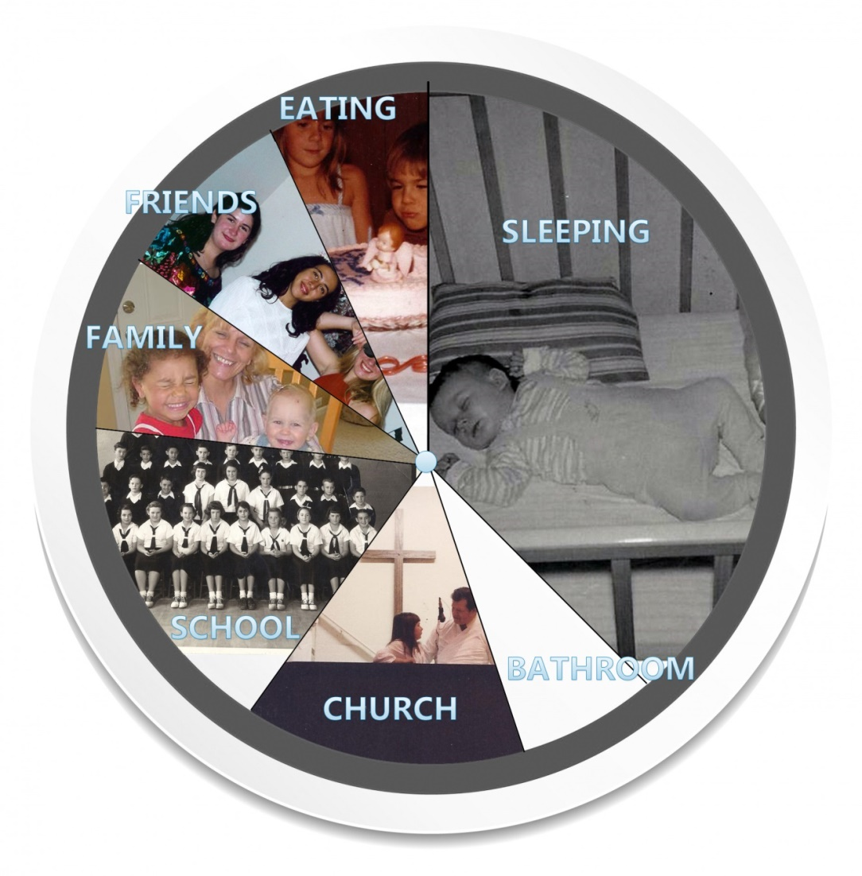

This is a pie of my life. I spend almost a third of it sleeping. To be truthful, when I can get away with it, I spend a lot more than that. I usually skip breakfast (I know, I know), but eat a good dinner. I also eat lunch at school, but that is not so good. We have church on Sundays and Wednesday nights. Plus I am pretty good about having a daily quiet time. School takes up a big chunk of my day, but when it is averaged out with the weekends, it doesn’t look so bad. It is still tiring. I like to spend time with my family. Sometimes my brother annoys me and my little sister won’t be quiet, but overall, they are a lot of fun to be with.

I also like to be with my friends. We play sports together, talk, listen to music, or just do nothing. Whatever it is, it’s always a good time. I spend a lot of time in the bathroom, taking showers, brushing teeth, combing hair, etc. Sometimes I like to take long baths and just think, so that bumps up this portion. Looking over the pie, I think I might need to spend less time looking in the mirror and combing my hair and more time sitting down to eat.

**Greatest Achievement to Date**

It is difficult to think of a great achievement at my age. Most of the things I have done seem pretty small. When I think of greatness, I think of George Washington at Valley Forge or that student who stood in front of the tanks in Tiananmen Square. My achievements are much smaller, but they are mine. One is when I went to Mexico with my parents and we helped build a church there. I learned a little Spanish ahead of time, and could at least say, "Buenos dias!" I really liked getting acquainted with the locals, and feeling that my hard work and sweat would help someone else. The church turned out very nicely. The Mexican Christians were a lot like us, and it seemed we didn’t need too many words to communicate. So that is probably my greatest achievement so far, building a church building.

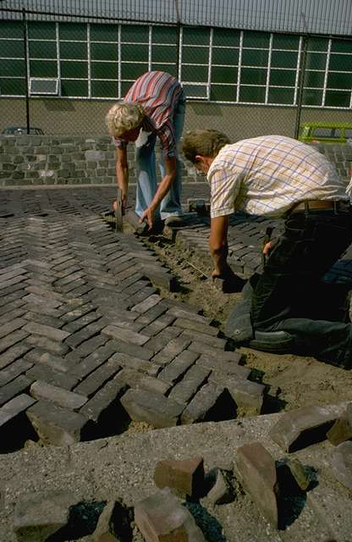I feel drawn to helping people. God has given me so very much and a lot of it seems like a waste when I look at how other people live in other places. I think that is what God wants from me—to help people. I am not sure how yet, but I am interested in other places, so maybe a doctor far away in a place I haven’t been to yet. Some missionaries from Missionary Aviation Fellowship came to our church not too long ago. One of them is a flying doctor who goes to little villages all over. That would be hard, but maybe interesting.

I am good at science and Latin, and I like to help my dad when he is doing things for other people. I don’t know what God has planned for me yet, but I really am interested in something to do with medicine.

Adobe House 2

**An Unusual Experience**

Okay, I know this is going to sound really weird, but it is true. The Bible says that angels walk among us. I think I met one once. I was at the beach with my friends and they got ready to leave. They were going a different way and I didn’t want to inconvenience them, so I said I would take the bus home. Of course it started to rain as soon as they left. Finally the bus showed up and I hurried on it. Then I reached for my money, and OH NO, there was a hole in my pocket. The bus driver did not seem like the kind who was going to let me ride for free. I felt a little panicked because it was a long way from home and I wasn’t going to be able to just walk, plus I was pretty sure my mom was going to be angry that I was alone. I didn’t know what I was going to do, but a lady in the front seat said she would pay for me. I swear she wasn’t there a moment before. She paid for me, and then got off the bus. She smiled really big as the bus pulled away, and then she disappeared. John says I just didn’t see her when I got on, but I still think she was an angel.

Another weird thing is that whenever my friend Jamie and I get together, radios get all staticky when we walk by. Really! Sometimes TVs will turn off, too. It only happens when we are together, never by ourselves. Strange, huh? I guess together we are just full of power!



**What Makes Me Happy**

You know, I’m a pretty happy guy! There are a lot of things that make me happy. Here are ten of them:

1. Sunshine when it is cold outside. I like the feel of the warmth on my face when I look up on a cold day.

2. Good music. I like lots of different kinds of music. There is a hymn I really like called “It is Well with my Soul”. And I like Chris Tomlin’s music; it makes me feel good. And I like Maroon 5. It all depends upon my mood. Beethoven’s music is the very best, though, and it never fails to bring a smile to my face.

3. Seeing my mom laugh. She is the serious one, so when she lets out a belly laugh, it is wonderful to see and hear it.

4. Gravy! I love gravy! Especially on mashed potatoes, but it’s also good on meat, on baked potatoes, on biscuits, and even on vegetables. Beef gravy is the best, but they are all good!

5. Lying in bed on Saturday morning knowing I don’t have to get up until I want to. I like being in that not-quite-awake, not-quite-asleep state. This is especially good on cold mornings when I am under a quilt and my dog is keeping me warm.

6. The Three Stooges. There will never be anyone funnier! They make me laugh every time I watch, even when I know what is going to happen.

7. Going to a football game with Dad. I don’t know if it is just spending the time with him, or if it is the game. It’s probably some of both. I love it when we can do this.

8. Shooting bulls-eyes. This doesn’t happen as often as I wish it did, but I’m getting better with the targets.

9. My PlayStation. I’m not supposed to write that, but it really does make me happy when I beat my best score.

10. The smell of a wood-burning fire. Isn’t that the best? I love making campfires, and I love roasting hot dogs on them. I like to get the outside of mine really crispy and black before I put tons of mustard on it. Yum!

**Leaving on a Jet Plane**

My own plane! The first place I am headed off to is Jackson, New Jersey. New Jersey? Oh yeah! It has the fastest roller coaster in the United States, Kingda Ka. It’s 456 feet high and goes 128 mph. I love roller coasters and am not afraid of any of them!

The next place I want to go is South Dakota. I’ve never been to Mount Rushmore. My mom went there when she was a little girl and it made such an impression on her that she still talks about it in awe. So I would really like to see it.

The last destination in North America would have to be Branson, Missouri. I hear a lot about it and think it sounds kind of interesting with all the shows and everything.

My parents traveled to London, and they came home and told us about

seeing the Changing of the Guard at Buckingham Palace, the Roman ruins at Bath, the great museum near the palace, Paddington Station, and all the British architecture. I think that I'd like to go there or actually anywhere there is history. 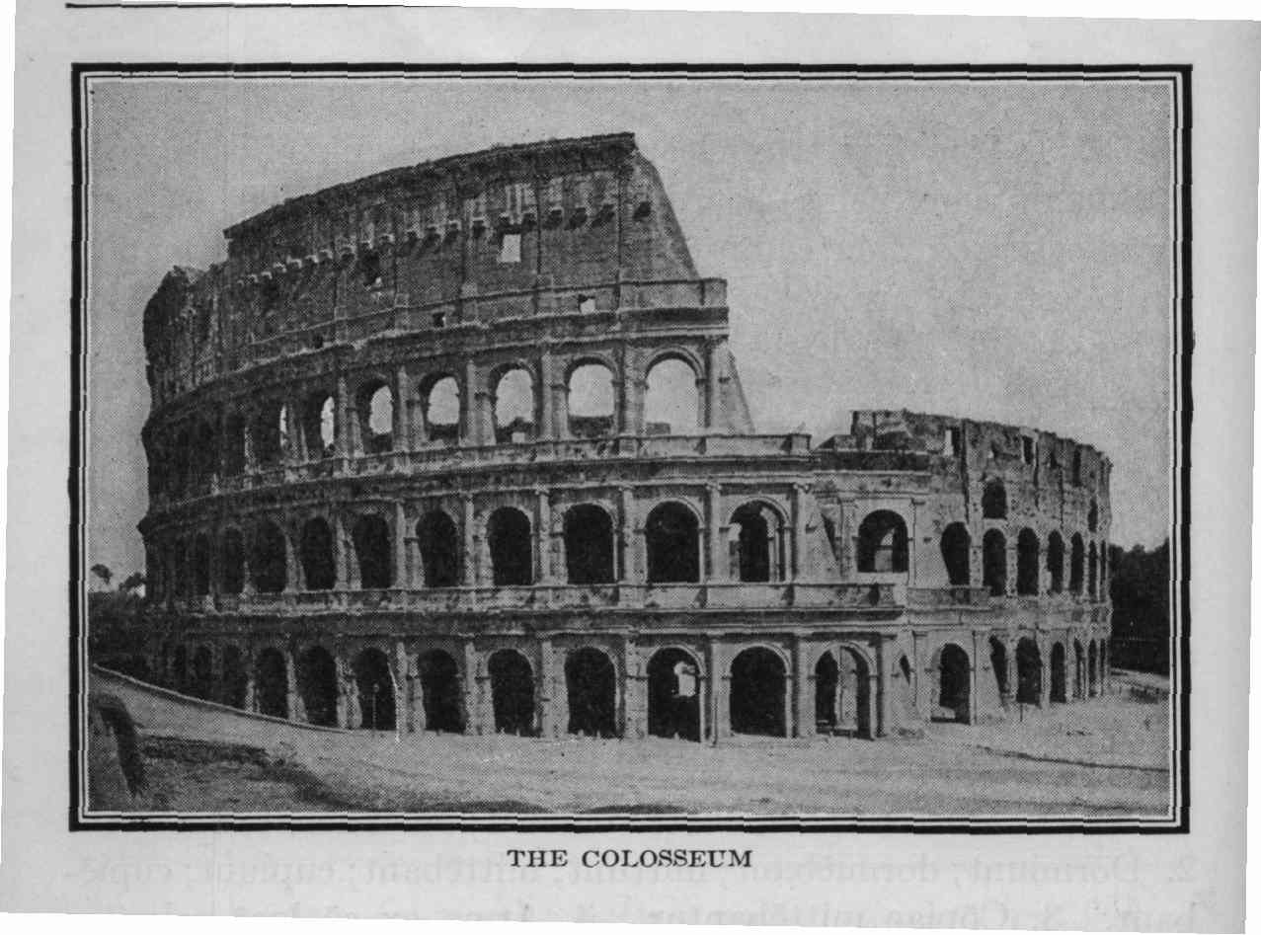I also would want to go to Rome and see the Colosseum, the Pantheon, the Forum, and other places I’ve been studying about.

I have also always wanted to go to Antarctica. I don’t know why. Maybe because it is so barren. It seems very interesting, and I would like to see all the different animals there. I don’t think I could take a jet there, though, so I would have to take a helicopter.

I think it would be very exciting to land a jet on an aircraft carrier, too! It would be kind of scary, but fun. Maybe by then, my brother John would be the pilot!

**People Who Have Influenced Me**

Why can’t my family be here? They are the people who have influenced me most! Other than them, the three people who have touched my life the most are my pastor, Doug; my Troopmaster, Mark; and my neighbor, Mrs. Molina.

Pastor Doug is a really godly man, but he is also down-to-earth. He is strong and does what is right even when it is not always popular. He preaches with a lot of passion and teaches straight from God’s Word. Another thing I like is that he tells it like it is. Do you remember that passage in Proverbs that talks about the wounds of a friend being sweeter than the kisses of an enemy? That’s how I feel sometimes. He wants me to be a godly man, too, and helps me know the truth, even when it can occasionally sting.

My Troopmaster is another godly man. He has taught me a lot of good things, not just about hiking and camping and outdoor stuff. He teaches us about loyalty, respect, and honor. He has sons in our troops, and he treats all of us like his sons. I really like to go to meetings and events, and I think I would like to be a lot like Mark when I grow older. He is funny, smart, and a good person.

Lastly, my neighbor Mrs. Molina has influenced me. Some of the kids in the neighborhood think she is weird, but they haven’t really taken the time to get to know her. She is very old; I think she must be about ninety. She walks very slowly and is a little hunched over. But she always has something nice to say, and hot chocolate when it’s cold outside. I go and visit her a couple of times a week. Sometimes we don’t do anything but have a cup of hot chocolate. A couple of times she hasn’t even talked. When I first met her, I thought maybe she didn’t speak English, but it is just that she doesn’t talk unless she has something to say. I think that is a good thing. A couple of times she has told me about her life and the stories are interesting. She likes to listen to me, too. I tell her all about what I am learning and what books I am reading. John says she is deaf and that is the only reason she likes to listen to me, but I think she cares. It’s kind of neat. Some of the kids will cross the street when she is outside so they don’t have to talk to her, but I always try to at least ride by and say, “Hi Mrs. Molina!” I think the world would be better if people listened to each other, and were not afraid to talk to their neighbors.

**If…**

If I had ten million dollars, the first thing I’d do is buy my mom and dad a ranch house. It couldn't be in California, or all the money would be used up! It would be huge, and have a separate house for a maid so my mom wouldn’t have to clean. I think maybe it would be in the Midwest or back in Michigan, where I could get a lot of house and land for the money. Then we would take a trip to Hawaii to see the volcanoes and surf. We would stay in the best hotel, and have room service every day including the biggest ice cream sundae they could make. I would rent a boat so we could all go and swim with the dolphins. I would buy the best surfboard and take lessons. Then I would make my own surfing movie. I wonder if it costs a lot to buy those cameras that can go in the water.

I wouldn’t leave my brother and sisters out. I would buy John his own airplane. One of the good ones so that I wouldn’t worry about riding in it with him. I would buy Jenna her own horse at my parents’ new house, so I guess their house would have to have stables, too. I would buy Michelle a karaoke machine, so she can sing and talk to her heart’s content. I think maybe I would have a soundproof room built onto my parents’ house just for her so she could sing and talk all day long without having to be quiet.

I would rent out the whole zoo so for a week so I could be the zookeeper. Everyone could come and visit and I would teach them all about the different animals. I know a lot about all different kinds of animals from reading and watching tv shows about them.

I would finally think of others, and decide to give some money to Boys Town in Nebraska where they help underprivileged kids. I remember my Uncle Mike told me to give the first 10% to church, and put the second 10% in the bank, and live on the other 80%. So, I will take his advice except the bank’s 10% will go to charity.

It feels good to give away money to people I care about, and it feels *really* good to spend it!

If I were President for a day, the first thing I would do is pray. There are presidents in our past that did so, and I think their legacies are much better than those who didn’t. Next, I would do whatever I could to push to get a fair-tax system in place. Lastly, I would try to retire a couple of Supreme Court Justices and replace them. It’s only one day, but you have to do what you can.



If I could change one thing about me, I think I would like to be taller. That might happen! But for now, my height hasn’t caught up with the size of my feet. Sometimes when I am running, I think I look like I have clown feet. So I would change my height so it matches my feet.

Of course, if I could go back in time, I would like to meet Jesus. I would love to have things cleared up and questions I have answered fully. Sometimes I ask my dad about things and mostly he is able to answer. But sometimes the questions are even too hard for him. I would like to ask Jesus what the world was like when it was new, and before it was formed.

I would also like to meet Napoleon Bonaparte. He was a brilliant commander and strategist.

Lastly, I would like to meet Charles Spurgeon. I listen to his sermons online sometimes. They are very difficult to understand, but mom says it is “top shelf” learning; that I have to reach for it. I think it would be great to hear him in person.

Oh no, it’s Freaky Friday! I don’t really want to change places with anyone! But if I have to, I guess I would change with my brother, John. It might be nice to be the “big brother” for a day instead of the “little brother.” But I would definitely want to change back after a day!

**Whom Do You Admire?**

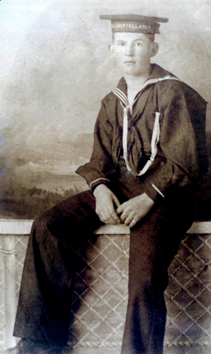

Former President Bush is one person I admire. He had to lead our country in war, and he was criticized a lot for doing it. He tried to appoint pro-life judges and had a hard time getting them through. He seems like a regular person, and a really good person. I would like to meet him one day. His actions show that he is a godly man, and a man who prays. He is also not afraid to talk about his faith or about Jesus. A lot of public figures talk about God, but it sounds generic. George Bush actually talked about Jesus Christ. I think he is a good man, even though I don’t agree with him about everything (nobody agrees with anyone completely, do they?) Besides, he looks like my great-great-grandpa, don't you think?

Another person I admire is Robert E. Lee. Even though he didn’t like war and didn’t want to fight, he stood up for what he believed in. I think it is sad that after the war his land was made into a cemetery so that his family could never get it back.

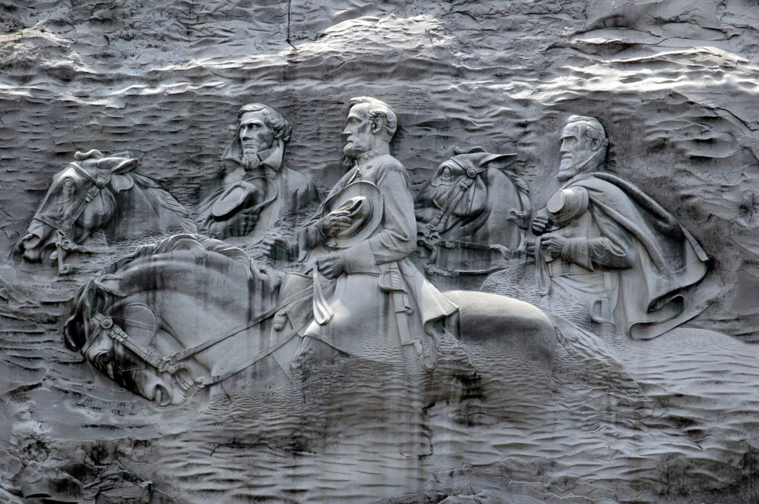

**My Future**

Five years from now, I will be graduating! It seems kind of strange to think about it. Then it is off to college. I haven’t really thought about where yet, or if it might be better to go through the Marine Corps instead.

In fifteen years, I’ll be getting close to thirty. I will probably just be starting my medical practice. If I join the Marine Corps like my grandfather, then I would be wherever they put me. I might go to a good medical school and be doing my residency in a big hospital. Or God might call me to the mission field. It is so hard to know. I think I will be married to a great girl who is a Christian and who loves me and thinks my jokes are funny. Someone who laughs at my corny jokes will be difficult to find, but it is how I will know she is the right one. Her inner beauty will show on the outside because of reflecting God’s love, and I would like it if she had big, brown eyes. And she will be shorter than I am. And will definitely have smaller feet than mine!

In twenty-five years, I will have as big a family as God will give us, and we will probably homeschool all of them or put them in a Christian school. My wife will have to be a strong woman, too, especially if we are missionaries. I will be all finished with all my schooling and my career will be established. I think the 40s will be a very good time in life.

**When I’m 80**

After a long career, I can look back upon my life and know that although hard times came into my life, they were to help me grow as a Christian. I would tell my grandson to depend upon God totally, and that He will never fail him.

My family would be grown now, and they would truthfully be the joy of my life. I would tell my great-grandson that family is more important than anything that money can buy. My wife would be my faithful friend and companion in life, just as we were designed to be for each other. We would still help people wherever we can, and find much happiness in our family and ministries. I like that saying, "The Best Is yet to Come." So I would tell him to always look forward. The words of warning I would give him would be to be wise about people. Everybody is a sinner and people do not always tell the truth, so be careful. And be forgiving when someone messes up because everybody does. But that he should hold people accountable for what they do. Forgive them, but help them to do better.

**Epitaph**

On my tombstone, if I had to choose a phrase to be engraved, it would be "Well done, thou good and faithful servant." I hope I live a life to deserve it. If I were going to choose three words, they would be Servant, Leader, Son. I try really hard to serve others. It doesn’t always come naturally, but I try to do a good deed every day. Next is Leader. That does come naturally. Last is Son. Son of my father and mother, and Son in the Kingdom of God. RIP is for Rest in Peace, which is what I’ll be doing.

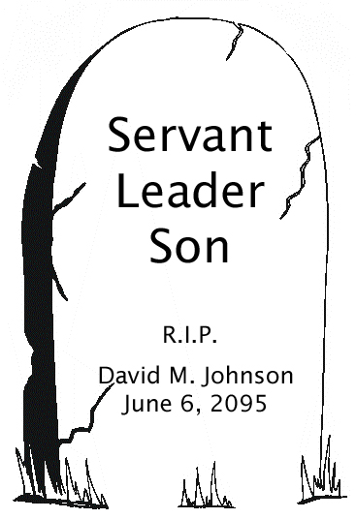

**Fictional Story**

\**An Adventure story that is totally made up, starring YOU. It may be a spy story or a trip to the moon. Something fairly unrealistic. The more fantastic, the better!*

*Some of those we have particularly enjoyed are:*

*An Alien in Mrs. Hawley’s English Class – Me!*

*The Adventures of Super Dog and Pup Wonder*

*008 -- The Real Story*

*How I Invented the Internet*

*Around the World in 180 Minutes*

*Why I Let Beethoven Take All the Credit*